FARM MANAGEMENT SYSTEM

User Story:
In the Farm Management System (FMS), as a farmer, farm manager, or system administrator, I want to use a centralized Salesforce-based platform to record and manage farm, crop, farmer, and buyer information so that all agricultural data is stored securely and systematically. I want to enter and update farm details, crop production records, and buyer transactions easily through a user-friendly interface with proper validation rules to prevent incorrect entries. I also want the system to generate real-time reports and interactive dashboards so that I can analyze farm productivity, monitor sales, and make informed decisions. Additionally, I want role-based access and secure data storage to ensure that sensitive information is protected while enabling smooth collaboration among users. This system will help reduce manual paperwork, minimize errors, improve efficiency, and support data-driven farm management.

1. INTRODUCTION

1.1 Project Overview :

The Farm Management System (FMS) is a Salesforce-based application designed to digitize and streamline agricultural operations. It manages data related to farms, crops, farmers, and buyers while providing real-time insights through reports and dashboards. The system helps farmers and managers monitor agricultural activities efficiently and make informed decisions.

1.2 Purpose :

The main purpose of this project is to:

Digitize agricultural data management

Improve data accuracy and accessibility

Automate record handling

Enable real-time monitoring

Support data-driven farming decisions

Enhance productivity and transparency

2. IDEATION PHASE
2.1 Problem Statement (Customer Problem Statement Template)

PS | I am (Customer) | I’m trying to | But | Because | Which makes me feel
PS-1 | Farmer | Maintain farm and crop records | Data is often incomplete or incorrect | Records are kept manually in registers | Frustrated and confused
PS-2 | Farm Manager | Monitor farm productivity and sales | Reports are delayed and inaccurate | Data is scattered across files and sheets | Stressed and inefficient
PS-3 | Buyer | Access crop availability and pricing | Information is not updated regularly | There is no centralized digital system | Uncertain and dissatisfied
PS-4 | System Admin | Manage user access and system security | Unauthorized access may occur | Access control is handled manually | Concerned and insecure

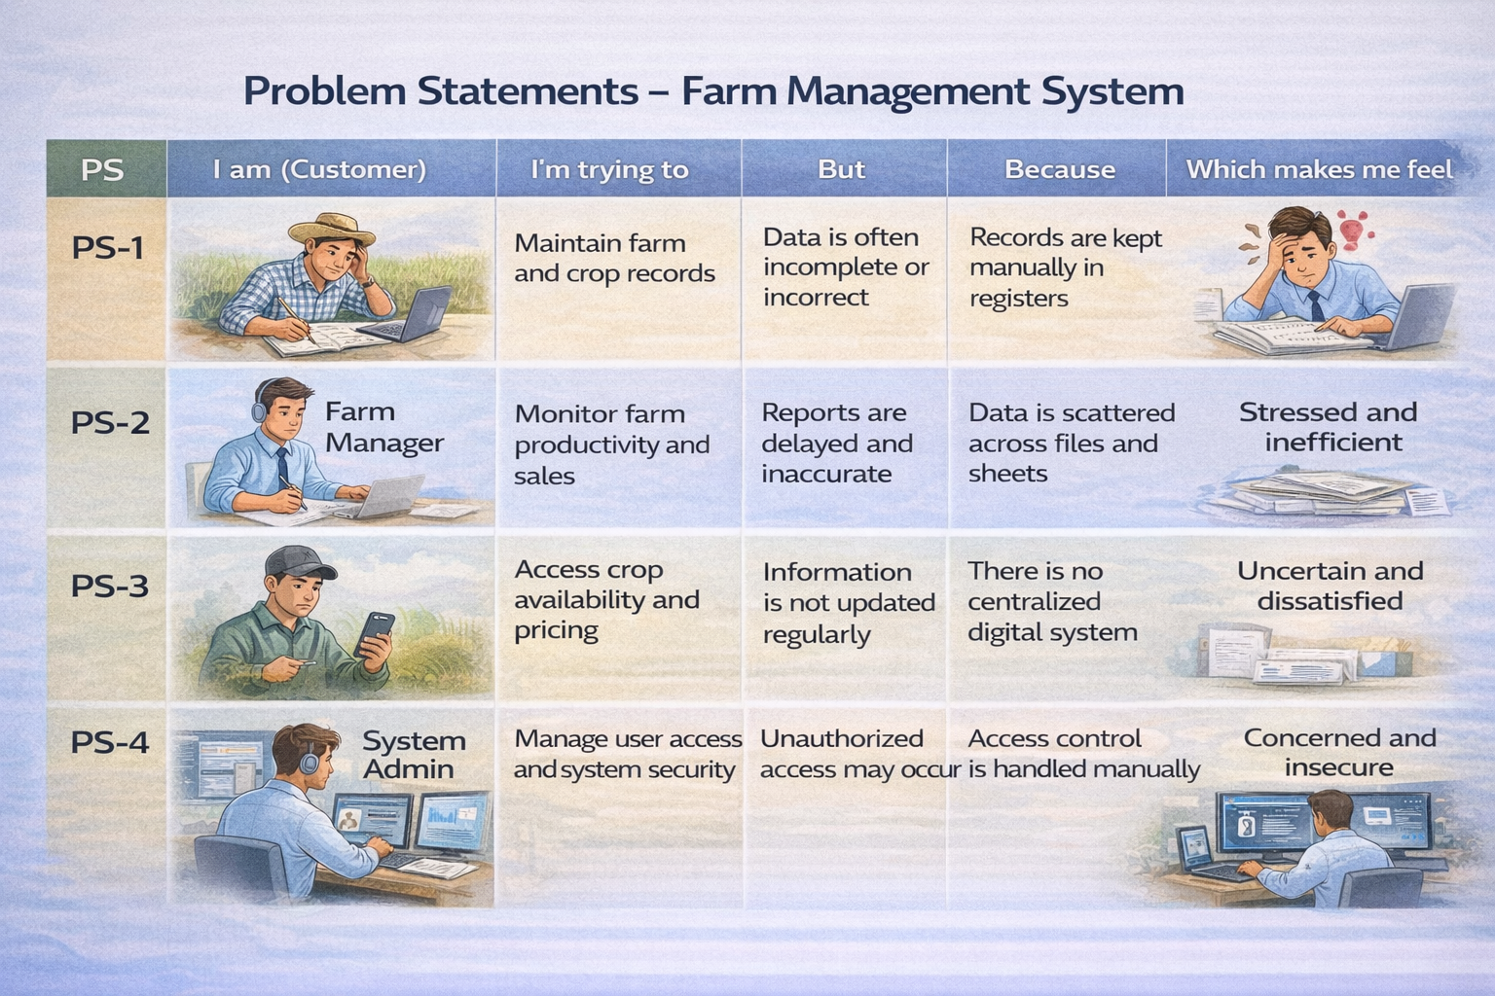

2.2 Empathy Map Canvas
Target Users:

Farmers

Farm Managers

Buyers

System Administrators

Empathy Analysis

Think & Feel: Need accurate and timely farm data

Hear: Feedback from agricultural officers

See: Registers, paper files, spreadsheets

Say & Do: Enter records manually

Pain: Data loss, errors, delays

Gain: Automation, fast reporting

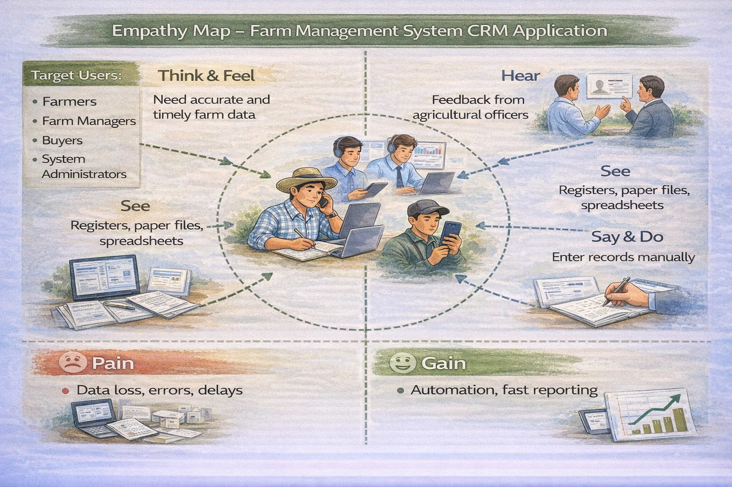

2.3 Brainstorming
Brainstormed Ideas

Manual farm records

Excel-based management

Web-based system

Mobile farm app

Salesforce-based FMS

Selected Idea
Salesforce-based Farm Management System.

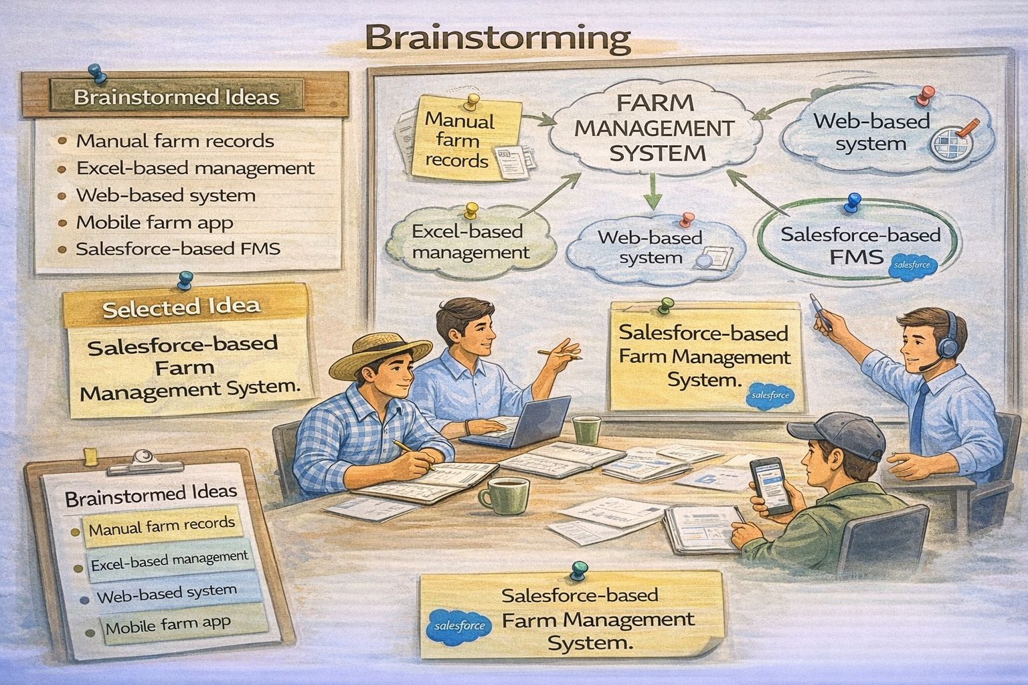

3.REQUIREMENT ANALYSIS PHASE

3.1 Customer Journey Map
Stages:

Login

Access Farm Management App

Enter Farm and Crop Data

Register Farmers and Buyers

Generate Reports

Analyze Results

Decision Making

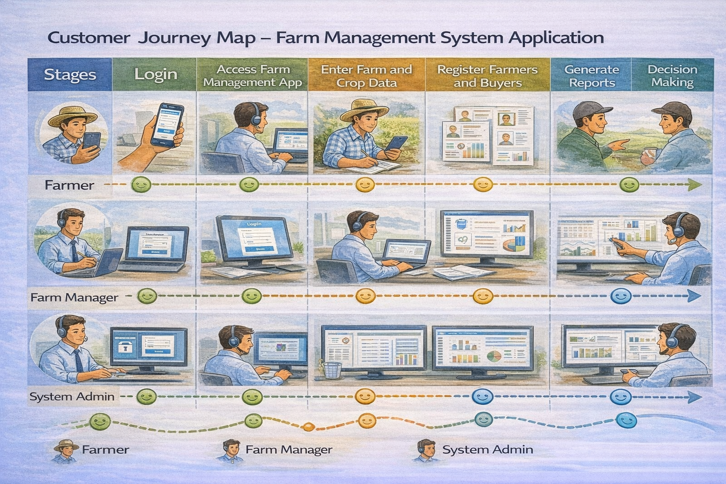

3.2 Solution Requirements
Functional Requirements

FR No | Requirement
FR-1 | User Authentication
FR-2 | Farm, Crop, Farmer, Buyer Management
FR-3 | Data Entry and Validation
FR-4 | Relationship Mapping
FR-5 | Report Generation
FR-6 | Dashboard Visualization
FR-7 | User Role Management

Non-Functional Requirements

NFR | Description | Example
Usability | Easy interface | Simple Lightning UI
Security | Data protection | Profiles & roles
Reliability | No data loss | Cloud backup
Performance | Fast access | Reports in <3 sec
Availability | 24/7 access | Cloud hosting
Scalability | Handles growth | More farms/users

3.3 Data Flow Diagram
Data Flow:
User → Salesforce UI → Custom Objects (Farm, Crop, Farmer, Buyer) → Validation Rules → Relationships → Reports → Dashboards
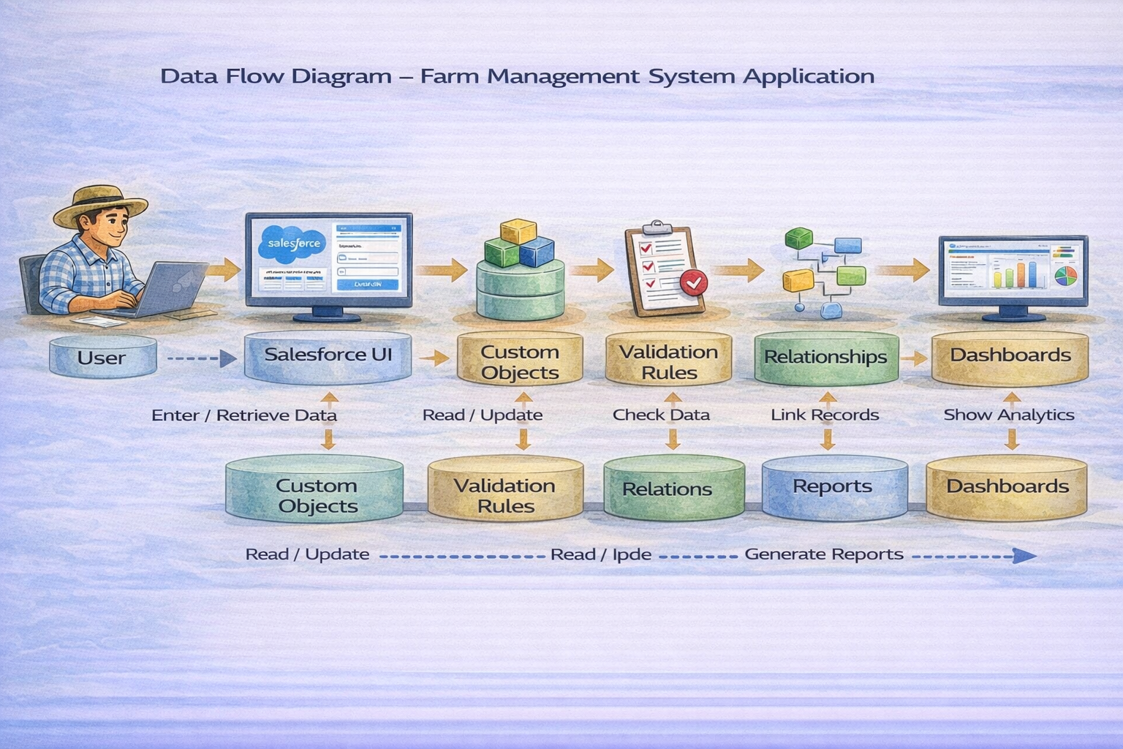

3.4 Technology Stack
Layer | Technology
Frontend | Salesforce Lightning UI
Backend | Salesforce Platform
Database | Salesforce Cloud
Automation | Validation Rules
Analytics | Reports & Dashboards

4. PROJECT DESIGN PHASE

4.1 Problem–Solution Fit
The FMS replaces manual farming records with automated data management. Cloud storage prevents data loss, dashboards improve analysis, and real-time reports eliminate delays. This ensures accurate and timely agricultural insights.
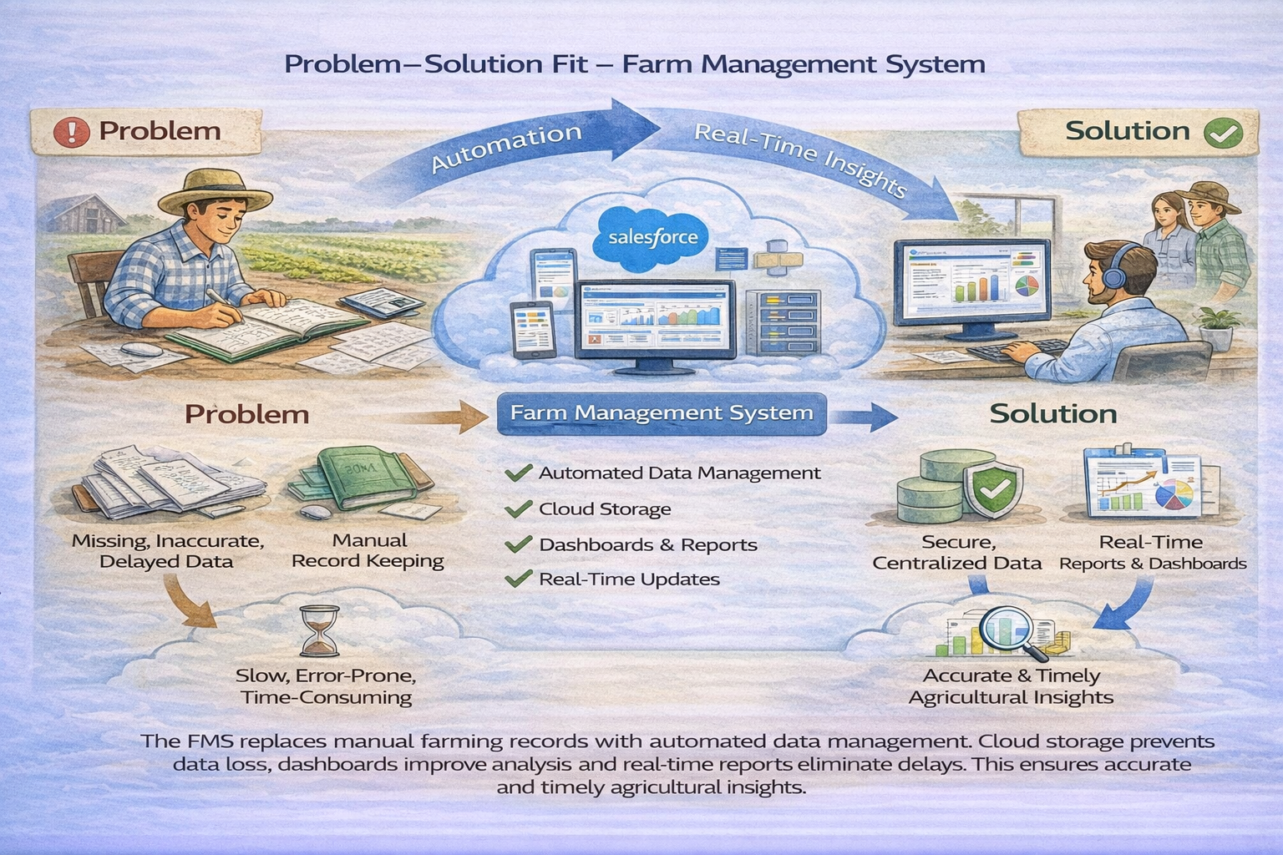

4.2 Proposed Solution
Functional Requirements
Parameter | Description
Problem | Manual maintenance of farm, crop, farmer, and buyer records leading to errors, data loss, and delays.
Solution | Salesforce-based Farm Management System with centralized data storage and automation.
Innovation | Automated data entry validation, cloud storage, and real-time reporting dashboards.
Impact | Improved data accuracy, faster reporting, and better decision-making for farmers and managers.es
Business Model | Digital farm management and agricultural data services platform.
Scalability | Supports multiple farms, users, and regions with cloud-based infrastructure.

4.3 Solution Architecture
Architecture Layers

Presentation Layer – Salesforce Lightning UI

Application Layer – Validation Rules, Relationships

Data Layer – Custom Objects

Analytics Layer – Reports and Dashboards

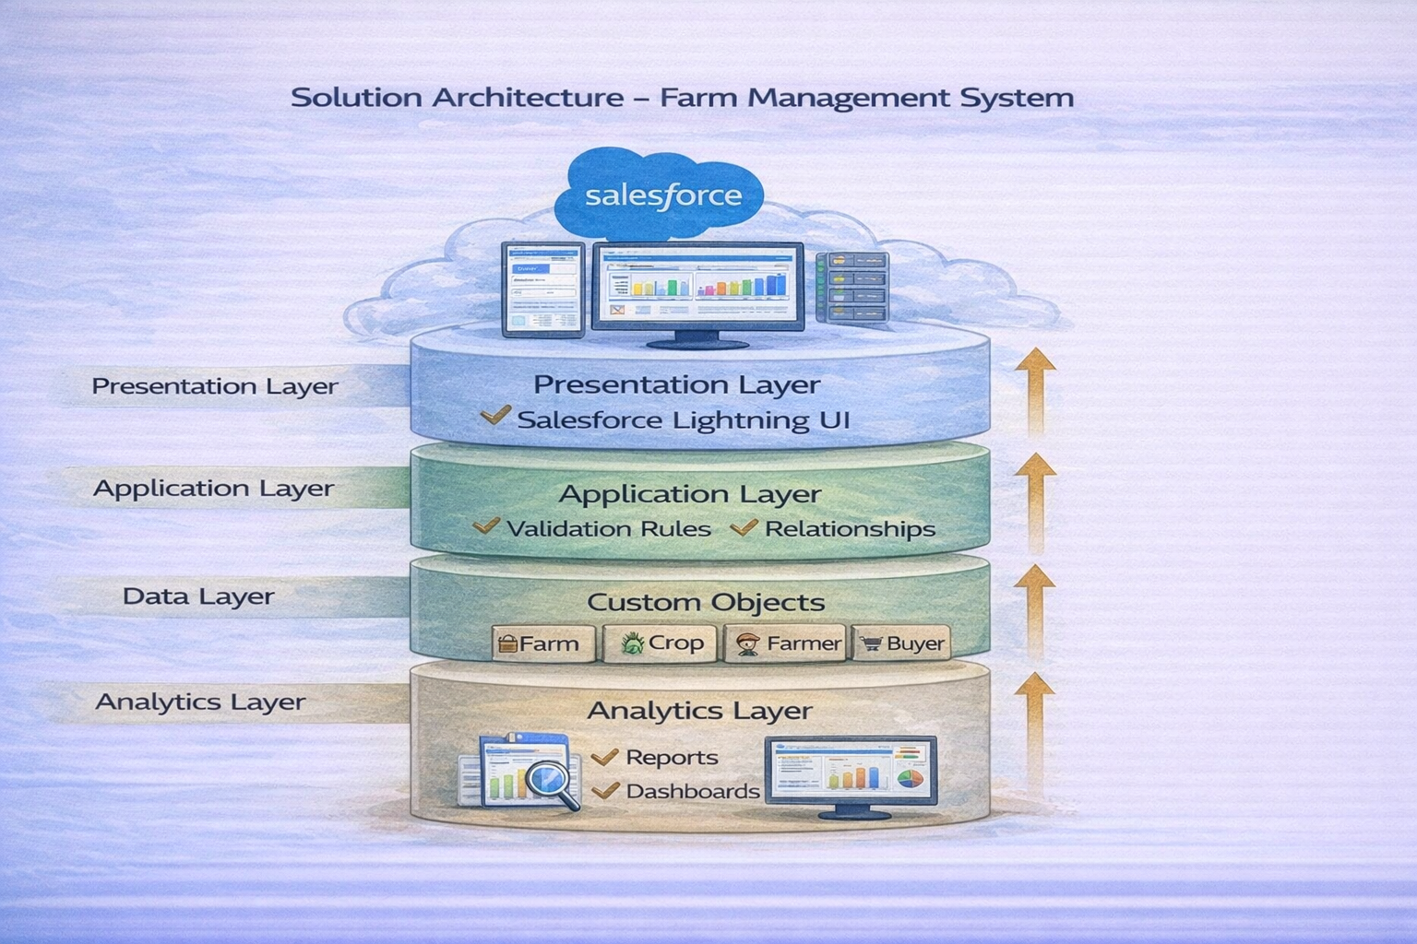

5. PROJECT PLANNING & SCHEDULING

5.1 Project Planning

Created Salesforce Developer Org

Developed custom objects

Configured tabs and Lightning App

Created fields and relationships

Designed profiles and roles

Created users and sharing rules

Developed reports and dashboards

Conducted testing and reviews

Product Backlog, Sprint Schedule, and Estimation (4 Marks)
Use the below template to create product backlog and sprint schedule
Sprint | Functional Requirement (Epic) | User Story Number | User Story / Task | Story Points | Priority | Team Members
Sprint-1 | Developer Setup | USN-1 | As a system administrator, I want to create and configure a Salesforce developer account so that I can set up and deploy the Farm Management System. | 3 | High | Member1
Sprint-2a | Data Modeling | USN-2 | As an admin, I want to create Farm, Crop, Farmer, and Buyer objects with proper relationships so that agricultural data is stored and managed efficiently. | 5 | High | Member2
Sprint-2 | Data Modeling | USN-3 | As a staff member, I want tabs and a Lightning App for all farm modules so that I can easily navigate and perform daily operations. | 5 | High | Member3
Sprint-3 | Automation | USN-4 | As a system, I want to validate farm and crop details such as dates, quantities, and mandatory fields so that incorrect or incomplete records are prevented. | 3 | High | Member4
Sprint-3 | Automation | USN-5 | As a manager, I want automated flows for crop updates and buyer notifications so that farm operations are processed faster without manual intervention. | 3 | High | Member4
Sprint-4 | Security | USN-6 | As an administrator, I want role-based access control for farmers, managers, and buyers so that sensitive farm and transaction data is secure. | 5 | High | Member2
Sprint-5 | Reports | USN-7 | As a farm manager, I want reports showing crop yield, sales, and buyer transactions so that I can monitor farm performance and make informed decisions. | 4 | High | Member3
Sprint-6 | Dashboards | USN-8 | As a farm manager, I want dashboards showing crop productivity, sales trends, and operational statistics so that I can monitor performance visually. | 4 | Medium | Member4

Project Tracker, Velocity & Burndown Chart: (4 Marks)
Sprint | Total Story Points | DuraFARM MANAGEMENT SYSTEM  User Story:  In the Farm Management System (FMS), as a farmer, farm manager, or system administrator, I want to use a centralized Salesforce-based platform to record and manage farm, crop, farmer, and buyer information so that all agricultural data is stored securely and systematically. I want to enter and update farm details, crop production records, and buyer transactions easily through a user-friendly interface with proper validation rules to prevent incorrect entries. I also want the system to generate real-time reports and interactive dashboards so that I can analyze farm productivity, monitor sales, and make informed decisions. Additionally, I want role-based access and secure data storage to ensure that sensitive information is protected while enabling smooth collaboration among users. This system will help reduce manual paperwork, minimize errors, improve efficiency, and support data-driven farm management.  1. INTRODUCTION  1.1 Project Overview :  The Farm Management System (FMS) is a Salesforce-based application designed to digitize and streamline agricultural operations. It manages data related to farms, crops, farmers, and buyers while providing real-time insights through reports and dashboards. The system helps farmers and managers monitor agricultural activities efficiently and make informed decisions.  1.2 Purpose :  The main purpose of this project is to:  Digitize agricultural data management  Improve data accuracy and accessibility  Automate record handling  Enable real-time monitoring  Support data-driven farming decisions  Enhance productivity and transparency  2. IDEATION PHASE  2.1 Problem Statement (Customer Problem Statement Template)  2.2 Empathy Map Canvas  Target Users:  Farmers  Farm Managers  Buyers  System Administrators  Empathy Analysis  Think & Feel: Need accurate and timely farm data  Hear: Feedback from agricultural officers  See: Registers, paper files, spreadsheets  Say & Do: Enter records manually  Pain: Data loss, errors, delays  Gain: Automation, fast reporting  2.3 Brainstorming  Brainstormed Ideas  Manual farm records  Excel-based management  Web-based system  Mobile farm app  Salesforce-based FMS  Selected Idea  Salesforce-based Farm Management System.  3.REQUIREMENT ANALYSIS PHASE  3.1 Customer Journey Map  Stages:  Login  Access Farm Management App  Enter Farm and Crop Data  Register Farmers and Buyers  Generate Reports  Analyze Results  Decision Making  3.2 Solution Requirements  Functional Requirements  Non-Functional Requirements  3.3 Data Flow Diagram  Data Flow:  User → Salesforce UI → Custom Objects (Farm, Crop, Farmer, Buyer) → Validation Rules → Relationships → Reports → Dashboards  3.4 Technology Stack  4. PROJECT DESIGN PHASE  4.1 Problem–Solution Fit  The FMS replaces manual farming records with automated data management. Cloud storage prevents data loss, dashboards improve analysis, and real-time reports eliminate delays. This ensures accurate and timely agricultural insights.  4.2 Proposed Solution  Functional Requirements  4.3 Solution Architecture  Architecture Layers  Presentation Layer – Salesforce Lightning UI  Application Layer – Validation Rules, Relationships  Data Layer – Custom Objects  Analytics Layer – Reports and Dashboards  5. PROJECT PLANNING & SCHEDULING  5.1 Project Planning  Created Salesforce Developer Org  Developed custom objects  Configured tabs and Lightning App  Created fields and relationships  Designed profiles and roles  Created users and sharing rules  Developed reports and dashboards  Conducted testing and reviews  Product Backlog, Sprint Schedule, and Estimation (4 Marks)  Use the below template to create product backlog and sprint schedule  Project Tracker, Velocity & Burndown Chart: (4 Marks)  tion | Sprint Start Date | Sprint End Date (Planned) | Story Points Completed (as on Planned End Date) | Sprint Release Date (Actual)
  PS | I am (Customer) | I’m trying to | But | Because | Which makes me feel
  PS-1 | Farmer | Maintain farm and crop records | Data is often incomplete or incorrect | Records are kept manually in registers | Frustrated and confused
  PS-2 | Farm Manager | Monitor farm productivity and sales | Reports are delayed and inaccurate | Data is scattered across files and sheets | Stressed and inefficient
  PS-3 | Buyer | Access crop availability and pricing | Information is not updated regularly | There is no centralized digital system | Uncertain and dissatisfied
  PS-4 | System Admin | Manage user access and system security | Unauthorized access may occur | Access control is handled manually | Concerned and insecure
  FR No | Requirement
  FR-1 | User Authentication
  FR-2 | Farm, Crop, Farmer, Buyer Management
  FR-3 | Data Entry and Validation
  FR-4 | Relationship Mapping
  FR-5 | Report Generation
  FR-6 | Dashboard Visualization
  FR-7 | User Role Management
  NFR | Description | Example
  Usability | Easy interface | Simple Lightning UI
  Security | Data protection | Profiles & roles
  Reliability | No data loss | Cloud backup
  Performance | Fast access | Reports in <3 sec
  Availability | 24/7 access | Cloud hosting
  Scalability | Handles growth | More farms/users
  Layer | Technology
  Frontend | Salesforce Lightning UI
  Backend | Salesforce Platform
  Database | Salesforce Cloud
  Automation | Validation Rules
  Analytics | Reports & Dashboards
  Parameter | Description
  Problem | Manual maintenance of farm, crop, farmer, and buyer records leading to errors, data loss, and delays.
  Solution | Salesforce-based Farm Management System with centralized data storage and automation.
  Innovation | Automated data entry validation, cloud storage, and real-time reporting dashboards.
  Impact | Improved data accuracy, faster reporting, and better decision-making for farmers and managers.es
  Business Model | Digital farm management and agricultural data services platform.
  Scalability | Supports multiple farms, users, and regions with cloud-based infrastructure.
  Sprint | Functional Requirement (Epic) | User Story Number | User Story / Task | Story Points | Priority | Team Members
  Sprint-1 | Developer Setup | USN-1 | As a system administrator, I want to create and configure a Salesforce developer account so that I can set up and deploy the Farm Management System. | 3 | High | Member1
  Sprint-2a | Data Modeling | USN-2 | As an admin, I want to create Farm, Crop, Farmer, and Buyer objects with proper relationships so that agricultural data is stored and managed efficiently. | 5 | High | Member2
  Sprint-2 | Data Modeling | USN-3 | As a staff member, I want tabs and a Lightning App for all farm modules so that I can easily navigate and perform daily operations. | 5 | High | Member3
  Sprint-3 | Automation | USN-4 | As a system, I want to validate farm and crop details such as dates, quantities, and mandatory fields so that incorrect or incomplete records are prevented. | 3 | High | Member4
  Sprint-3 | Automation | USN-5 | As a manager, I want automated flows for crop updates and buyer notifications so that farm operations are processed faster without manual intervention. | 3 | High | Member4
  Sprint-4 | Security | USN-6 | As an administrator, I want role-based access control for farmers, managers, and buyers so that sensitive farm and transaction data is secure. | 5 | High | Member2
  Sprint-5 | Reports | USN-7 | As a farm manager, I want reports showing crop yield, sales, and buyer transactions so that I can monitor farm performance and make informed decisions. | 4 | High | Member3
  Sprint-6 | Dashboards | USN-8 | As a farm manager, I want dashboards showing crop productivity, sales trends, and operational statistics so that I can monitor performance visually. | 4 | Medium | Member4
  Sprint | Total Story Points | Duration | Sprint Start Date | Sprint End Date (Planned) | Story Points Completed (as on Planned End Date) | Sprint Release Date (Actual)
  Sprint-1 | 20 | 6 Days | 24 Oct 2022 | 29 Oct 2022 | 20 | 29 Oct 2022
  Sprint-2 | 20 | 6 Days | 31 Oct 2022 | 05 Nov 2022
  Sprint-3 | 20 | 6 Days | 07 Nov 2022 | 12 Nov 2022
  Sprint-4 | 20 | 6 Days | 14 Nov 2022 | 19 Nov 2022
Sprint-1 | 20 | 6 Days | 24 Oct 2022 | 29 Oct 2022 | 20 | 29 Oct 2022
Sprint-2 | 20 | 6 Days | 31 Oct 2022 | 05 Nov 2022
Sprint-3 | 20 | 6 Days | 07 Nov 2022 | 12 Nov 2022
Sprint-4 | 20 | 6 Days | 14 Nov 2022 | 19 Nov 2022

